Assignment 1

● Create a class Student in Student.java then add member variables studentName, collegeName of type String

● Add a member variable studentID of type int.

● Make all the member variables as private.

● Add a main method. And print a message “Successful”.

● Compile the class ● Run the class

Solution:

public class Student {  
 private String studentName, collegeName;  
 private int studentID;  
 public static void main(String [] args){  
 System.*out*.println("Successful");  
 }  
}

Output:

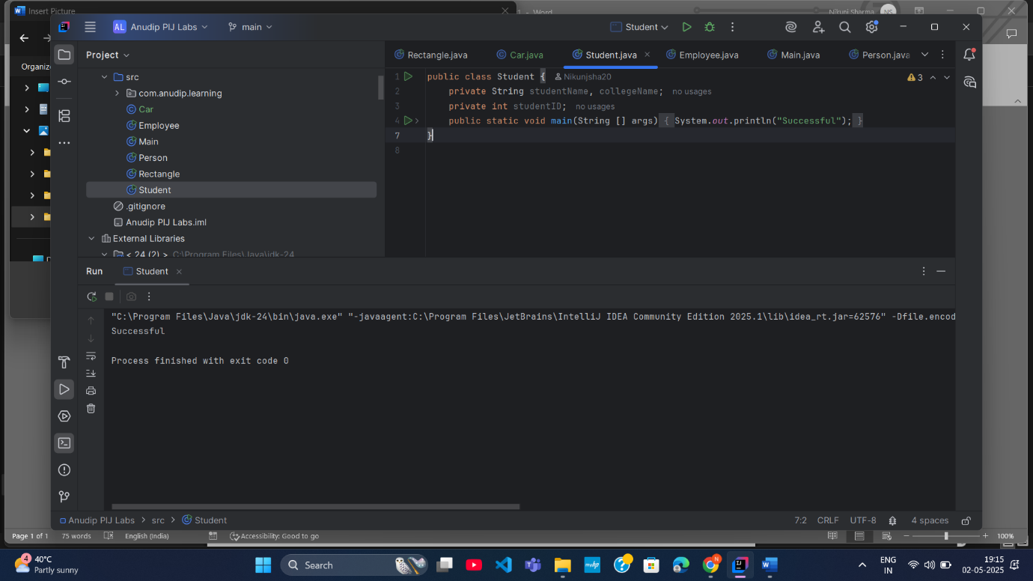

Assignment 2

● Create a new class Employee

● Add member variables: id and age of type int, name of type String and isPermanent of type boolean ● Now assign values 35.5 to age; See the error message.

● How can you avoid this error? Correct the error by casting.

● Make all the members protected

● Add a main method to it. Print message “Successfully started”.

● Compile the class.

Solution:

class Employee{  
 protected int id, age;  
 protected String name;  
 protected boolean isPermanent;  
 //age = 35.5; //java: <identifier> expected  
 protected float agE = (float) age;  
 public static void main(String[] args){  
 System.*out*.println("Successfully Started");  
 }

}

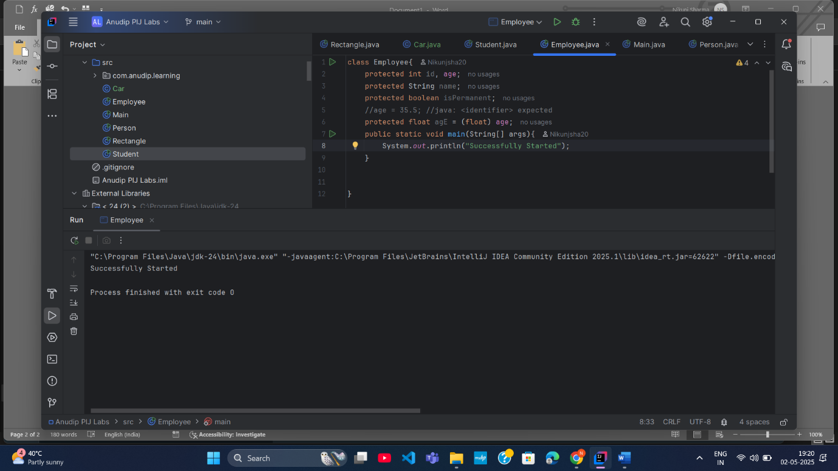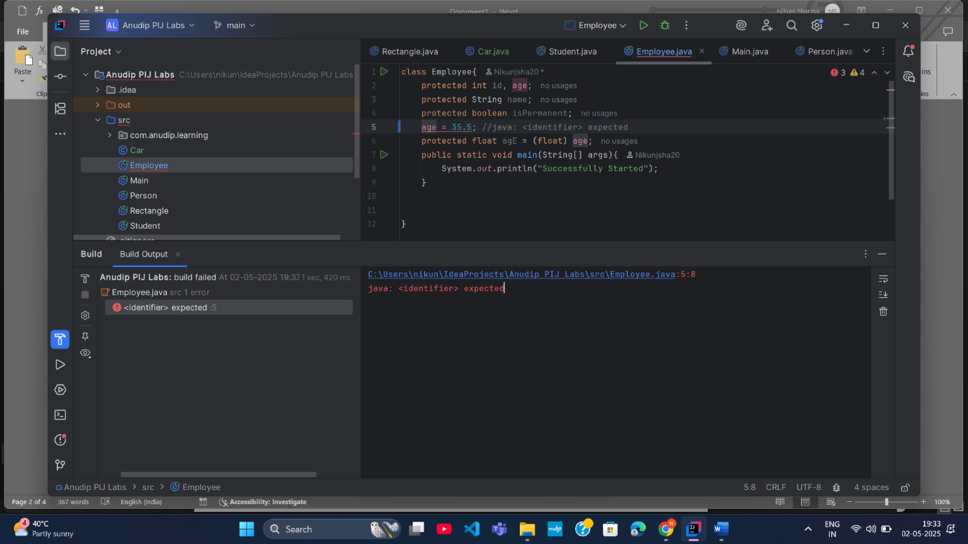

Assignment 3

● Create a class Person

● Add member variables name as String, age and salary as int

● Initialize the member variable along with declaration.

● Now put the previous Person class in a package com.anudip.learning

● Add a main method. Add a print message “Test Successful”.

● Run the class after compilation.

● Modify the classpaths to see the error messages on the console.

Solution:

public class Person {  
 String name = "Nikunj";  
 int age = 26, salary= 10000;  
 public static void main(String[] args){  
 System.*out*.println("Test Successful");  
 }  
  
  
  
}

Output:

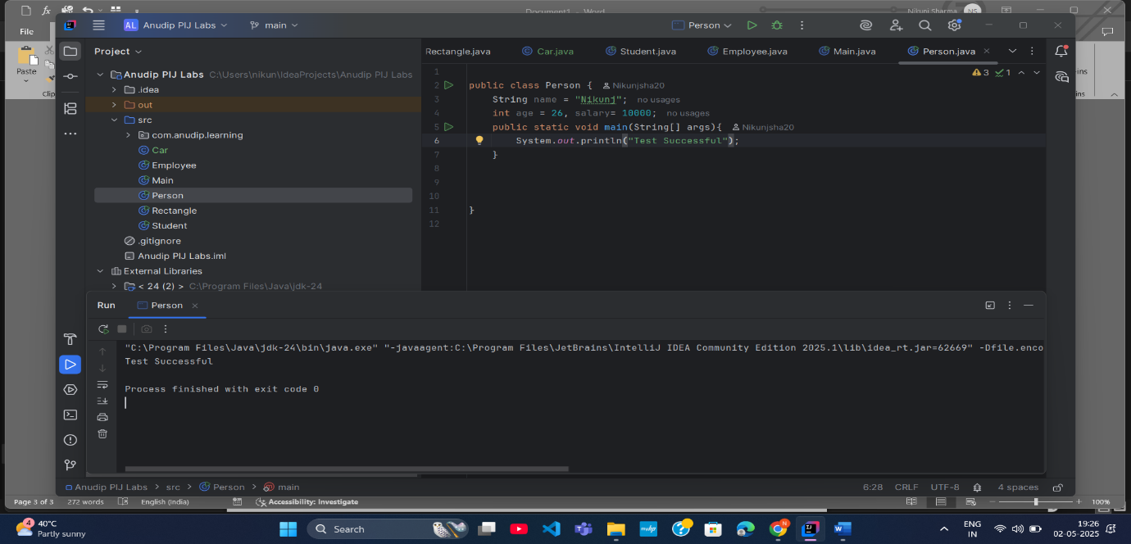

Assignment 4

● Create a class Rectangle

● Add a member variable width and height of type double.

● Create an enum Color with values RED, GREEN, BLUE

● Create a member variable boxColor of type Color.

● Add a main method.

● In main method just print the enum Color.BLUE (You will notice that Java prints the enum name as it is.)

● Compile and run the class.

Solution:

public class Rectangle {  
 double height, width;  
  
 enum Color{  
 *RED*, *GREEN*, *BLUE* }  
  
 Color boxcolor;  
 public static void main(String [] args){  
 System.*out*.println(Color.*BLUE*);  
 }  
  
}

Output:

